Exceptional Carpathian Mountain Estate
Luxury Property for Sale · Câmpina · Prahova Valley · Romania
A rare opportunity to acquire a grand private estate at the foot of the Carpathian Mountains, offering scale, privacy, and exceptional flexibility for refined living or high-end investment.
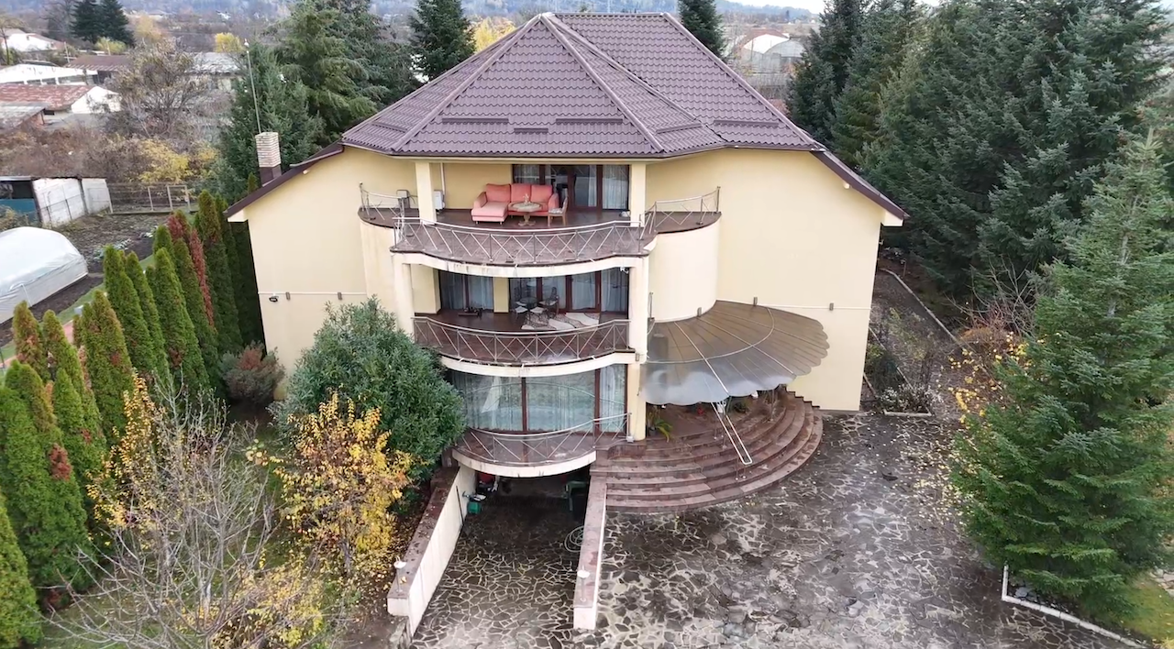

Prime Location
- 18 km from Sinaia & Busteni (Bucegi Mountains, Sphinx & Babele)
- 12 km from Paltinu Dam – Valea Doftanei
- 6 km from Telega Spa Resort (salt therapeutic baths)
- Approx. 80 km from Bucharest & Henri Coanda International Airport

Property Highlights
- Total built area: approx. 1,000 sqm
- Plot size: 3,200 sqm, fully enclosed
- 6 bedrooms & 7 bathrooms
- Grand living area
- Sauna, wine cellar, laundry room
- Technical room (pool & heating systems)
- Garage
- Outdoor swimming pool with waterfall and koi fish pond
- 100 sqm covered gazebo/taverna with 80 sqm basement
For further information or private viewing please contact:  Mr. Florian Barbu | Contact: Email: 247outreachllc@gmail.com  Phone: +40 (734) 041 227
YouTube: https://youtu.be/mZMs46yyQts?si=arGzFq2IZhxrxA_u

